Sorting, Selection , and Routing on the Array with Reconfigurable Optical Buses

Sanguthevar Rajasekaran and Sartaj Sahni
IEEE TRANSACTIONS ON PARALLEL AND DISTRIBUTED SYSTEMS, Vol. 8,NO. 11, Nov. 1997, p1123-1132

Abstract
In this paper, we present efficient algorithms for sorting, selection, and packet routing on the AROB (Array with Reconfigurable Optical Buses) model.

- Introduction

2. Sorting On The AROB
One of our sorting algorithms sorts n general keys in O(1) time on an AROB of size 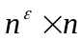for any constant > 0.

Algorithm column Sort

Step 1 : Sort columns
Step 2 : Transpose
Step 3 : Sort columns
Step 4 : Untranspose
Step 5 : Shift r/2
Step 6 : Sort columns
Step 7 : Unshift r/2
Step 8 : Sort columns
3. Selection
Our selection algorithm from out of n elements can be done in randomized O(1) time employing n processors.

 denotes the number of alive keys at the beginning of the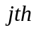 iteration
of the repeat loop.
 is the set of sample keys employed in the jth iteration.

Algorithm Select
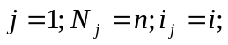
repeat
- Each alive key decides to include itself in the sample 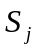.
- Compact the sample keys in the first row.
- Sort the numbers in the first row . Choose keys and 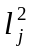 from with ranks 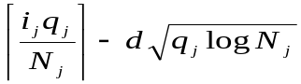 and 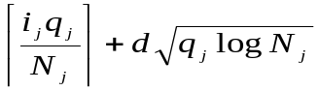
- Eliminate keys that fall outside the range [,]. Count the number, 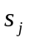, of surviving keys.
- Count the number 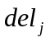 of keys deleted that are < . If the key to be
selected is not one of the remaining keys, start all over again .
(i.e., if > or > + )
until 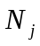 < 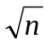
- Compact the surviving keys in the first row. Sort the first row and
output the th smallest key from out of the remaining keys.

4. Packet Routing
Our routing algorithm can route any h-relation in randomized O(h) time.

h-relation : h packets originate from any node and, at most, h packets
are destined for any node will be called h - h routing or h-relations

OCPC : Optical Communication Parallel Computer

Load_Balancing ( n , k , N ) : In an n-node network , there are at

most k packets at any node. Let N be the total number of packets.

To rearrange the packets , such that each node has ,at most, 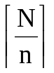packets.

Algorithm Route
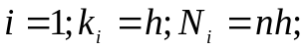
repeat
for= 1 to 1.5 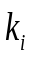 do
Step 1. Each processor does the following: It picks one of the remaining packets uniformly, at random, and sends it in the bus. Thus, there is a probability of  that any packet from will be sent.
Step 2. Reverse the direction of the above routing to inform the processors as to whether or not their packets have been successfully sent.
Perform load_balancing; compute 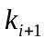 and 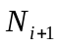 ; 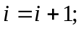
until 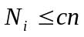 (c being a constant).

5. Conclusion
Created by : Kuen-Feng Huang
Date : Nov. 6, 1999

